**MANMEET KAUR**

**19945**

**MATH201 - Calculus-I**

**Homework Assignment #5**



Rewrite: ∫ 3x^(1/2) dx  
Integral: 3 * (2/3) * x^(3/2) = 2x^(3/2)  
Evaluate: [2x^(3/2)] from 4 to 9  
At x = 9: 2 * 9^(3/2) = 2 * 27 = 54  
At x = 4: 2 * 4^(3/2) = 2 * 8 = 16  
Result: 54 - 16 = **38**



Integral: x * ln(x) - x  
Evaluate: [x * ln(x) - x] from 1 to e  
At x = e: e * ln(e) - e = e * 1 - e = 0  
At x = 1: 1 * ln(1) - 1 = 0 - 1 = -1  
Result: 0 - (-1) = **1**



Integral: x * cos^(-1)(x) - √(1 - x^2)  
Evaluate: [x * cos^(-1)(x) - √(1 - x^2)] from 0 to 1  
At x = 1: 1 * cos^(-1)(1) - √(1 - 1^2) = 1 * 0 - 0 = 0  
At x = 0: 0 * cos^(-1)(0) - √(1 - 0^2) = 0 - 1 = -1  
Result: 0 - (-1) = **1**



Factor out π: π * ∫ cos(πx/2) dx from -1 to 1  
Use symmetry: 2 * ∫ cos(πx/2) dx from 0 to 1  
Substitute: u = πx/2 → du = (π/2)dx, dx = (2/π)du  
Limits: x = 0 → u = 0; x = 1 → u = π/2  
Integral: 2 * (2/π) * ∫ cos(u) du from 0 to π/2 = (4/π) * ∫ cos(u) du  
Integral of cos(u): sin(u)  
Evaluate: (4/π) * [sin(u)] from 0 to π/2  
At u = π/2: sin(π/2) = 1  
At u = 0: sin(0) = 0  
Result: (4/π) * (1 - 0) = 4/π  
Multiply by π: π * (4/π) = **4**



Substitute: u = x^3 → du = 3x^2 dx → x^2 dx = du/3  
Integral: (1/3) ∫ cos(u) du  
Integral of cos(u): sin(u)  
Result: (1/3) * sin(u) + C  
Substitute back: (1/3) * sin(x^3) + C = **(1/3) * sin(x^3) + C**



Substitute: u = 1 + sin(3t) → du = 3 * cos(3t) dt → cos(3t) dt = du/3  
Integral: (1/3) ∫ (1/u) du  
Integral of 1/u: ln|u|  
Result: (1/3) * ln|u| + C  
Substitute back: (1/3) * ln|1 + sin(3t)| + C = **(1/3) * ln|1 + sin(3t)| + C**

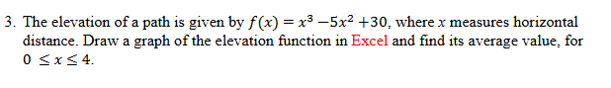

The elevation function is:  
f(x) = x^3 - 5x^2 + 30.

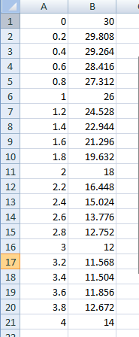

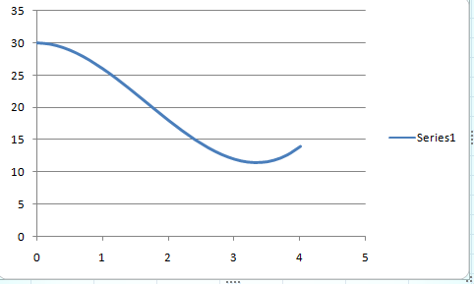

**3. Average Value of f(x)**

The formula for the average value of a function over an interval [a, b] is:

**Average Value** = (1 / (b - a)) * ∫[a to b] f(x) dx.

Here, a = 0 and b = 4.

**Integral of f(x):**

f(x) = x^3 - 5x^2 + 30  
Integral of f(x) = (1/4)x^4 - (5/3)x^3 + 30x + C.

**Evaluate the definite integral:**

∫[0 to 4] f(x) dx = [(1/4)x^4 - (5/3)x^3 + 30x] from 0 to 4.

At x = 4:  
(1/4)(4^4) - (5/3)(4^3) + 30(4) = (1/4)(256) - (5/3)(64) + 120  
= 64 - 106.67 + 120  
= 77.33.

At x = 0:  
(1/4)(0^4) - (5/3)(0^3) + 30(0) = 0.

So, ∫[0 to 4] f(x) dx = 77.33 - 0 = 77.33.

**Average Value:**

Average Value = (1 / (4 - 0)) * 77.33 = 77.33 / 4 = **19.33**.